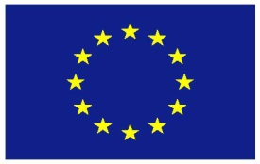

EU Key Messages
Arms Trade Treaty Working Group Meetings
Working Group on Transparency and Reporting
Geneva, 16-19 March 2026

Agenda item 2: Supporting compliance with ATT reporting obligations
I have the honour to speak on behalf of the EU and its Member States.

The candidate countries North Macedonia, Montenegro, Serbia, Albania and Republic of Moldova as well as the EFTA countries Iceland and Norway, members of the European Economic Area align themselves with this statement.
- The EU thanks Ms. Winkelried Salazar of Peru for assuming the role of WGTR Chair, and expresses appreciation for her effort to guide the discussion around clear-cut questions.
- The EU thanks the ATT Secretariat for presenting the current status of reporting and expresses its deep concern for the continued low rate of reporting.
- The EU remains a major provider of assistance towards ATT implementation and universalization. As an example of the EU’s recent involvement let me refer to the national assistance workshop for Colombia in early February held under the EU ATT Outreach Project, 4th phase. The workshop aimed at strengthening technical understandings of Article 13 and to enhance interagency coordination. A key outcome was the joint drafting of a national step-by-step guide to facilitate a coordinated, consistent and sustainable ATT reporting procedure.
- Let me reiterate that the EU stands ready to cooperate with all stakeholders and to build on guidance by States Parties on how to deliver our assistance most effectively. The EU would be pleased to contribute to any formal or informal setup considered by the Chair, such as a “sounding board”, to share its experience and coordinate regarding assistance in reporting.

North Macedonia, Montenegro, Serbia and Albania continue to be part of the Stabilisation and Association Process.

